Introduction
As a trade user, CBP allows for manifest and bill filings for truck cargo from a CBP trade facing portal and EDI messages (X12, EDIFACT, CUSCAR).

The CBP trade facing portal allows the trade user the ability to launch a web based manifest application from an ACE Portal account log in. Within the manifest application, ACE must provide the trade user with landing pages for manifest, bill of lading (BOL), party profiles, and vehicle profiles. Within each of these landing pages, the trade user must be able to create, edit, view, search, and filter the manifest data, BOL data, party profiles, and vehicle profiles.

This document is intended to describe the functionality within the trade facing CBP portal that CBP offers to trucking companies for manifest and bill of lading submission for standard manifests.

FAST/NCAP manifest data will still be submitted via EDI and not through the portal.

Table of Contents
1 Manifest Landing Page: 4
.Manifest Filters 5
.Manifest Search 5
2 Create a Manifest 7
.Manifest Header (Formally identified as Trip Information in Portal) 7
.Manifest Parties 8
.Manifest Vehicles 11
.Manifest Bills of Lading 14
.Linking a saved Bill of Lading 14
.Manifest Submission to CBP 14
.Create a Manifest or BOL from a Template 14
.Manifest History 14
3 Bill of Lading Landing Page 15
.Bill of Lading Filters 16
.Bill of Lading Search 16
.Bill of Lading History 18
4 Create a Bill of Lading 19
.Bill of Lading Header 19
.Bill of Lading Parties 21
.Bill of Lading Commodity Information 23
.Link a BOL to a saved Manifest 23
.Create a Bill of Lading Template 23
5 Party Profile Landing Page 24
.Party Profile Filters 24
.Party Profile Search 25
6 Party Profile Management 27
.Create Crew Members 28
.Edit Crew Members 29
.Create Shipper 29
.Edit Shipper 30
.Create Consignee 30
.Edit Consignee 30
7 Vehicle Profile Landing Page 31
.Vehicle Profile Filter 31
.Vehicle Profile Search 32
8 Vehicle Profile Management 34
.Create Conveyance 35
.Edit Conveyance 35
.Create Equipment 36
.Edit Equipment 36

Manifest Landing Page:
1.01 ACE must provide a manifest landing page which serves as the home page and provides trade the capability to view, filter, and search manifests created by the trade user.
1.02 The manifest landing page should default to show manifests in all statuses for the previous 90 days and the
1.03 Data elements to display should include:
- Filing Status
  - Preliminary
  - Submitted
  - Cancelled
- Prepared by Small Carrier Alpha Code (SCAC)
- Manifested SCAC
- Manifest Number
- Trip Status (Note: Will always display pre-arrival until the primary CBP Officer arrives the manifest.)
  - Pre-Arrival
  - Arrived
  - Held
  - Released
- Manifested Estimated date of Arrival
- Actual Arrival Date
- Manifested estimated Port of Arrival
- Actual Port of Arrival
- Manifested BOL Count
- Actions
  - Amend
  - Edit
  - Cancel
  - Print
1.03 Data Elements

Manifest Filters
1.04 ACE must provide quick filters that will sort the manifest list on the landing page by manifest status. Manifest status includes:

Manifest Search
- Preliminary (Not yet submitted to CBP)
- Submitted
- Cancelled
- All (default)
1.04 Manifest Status Filter Types
1.05 ACE must provide a way for the trade user to search the manifest landing page to refine the manifest records displayed. ACE must allow the trade user to search using the following criteria:
- Manifested SCAC
- Manifest Number
- Trip Status
  - Pre-Arrival
  - Arrived
  - Held
  - Released
- Filing Status
  - Preliminary
  - Submitted
  - Cancelled
- Port of Arrival
  - Manifested
  - Actual
- Date of Arrival
  - Manifested
  - Actual
- Crew Member
  - First Name
  - Last Name
- FAST Card Number
- Conveyance Plate Number
- Equipment Plate Number

1.05 Manifest Search Criteria

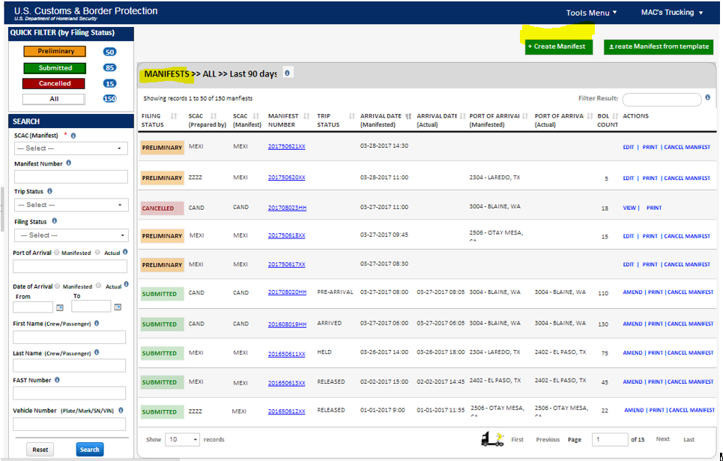1 Manifest Landing Page Mockup

2 Create a Manifest

2.01 ACE must provide the capability to create, edit, delete, and view a manifest including header information, the people in the truck, the conveyance and equipment, and cargo information.
2.02 ACE will use a Manifest Creation Wizard which allows a user to navigate between steps to add, edit, and delete information.
2.03 ACE must provide an option to save a manifest as a draft once a SCAC, manifest number, and estimated date of arrival have been entered by the trade user.
2.04 ACE will allow the manifest to be submitted to CBP once all the minimum required data is entered.
2.05 When saved as a draft, the manifest status will be set to “preliminary”. If submitted to CBP, the manifest status will be set to “submitted”.
2.06 ACE must provide the trade user the capability to create, edit, delete, and save a manifest template (without BOL information) to expedite the data entry process.
2.07 Using a saved template a user must be able to assign a unique trip number, add all required data, and link BOLs to the new manifest.

Manifest Header (Formally identified as Trip Information in Portal)
2.08 ACE must allow the trade user to select which SCAC code to create a manifest based on the users account authorities. If the trade user only has authority for a single SCAC code, ACE must default to that SCAC code.
2.09 ACE must allow a carrier to submit a manifest on behalf of another carrier. If this option is selected, the trade user should be able to type in the carrier SCAC code of the carrier that will cross the border.
2.10 (Note: Carrier accounts should be able to authorize within their account other carriers that are authorized to submit a manifest to CBP on their behalf. This does not apply to service provider account types. Creating this permission process would require work in accounts.)
2.11 ACE must display to the trade user the SCAC code and name of the carrier who prepared the manifest and the manifested carrier who will cross the border.
2.12 ACE must allow the trade user to provide a manifest number. The manifest number is up to 21 alpha numeric characters that will be combined with the SCAC code to make a valid “trip number” for CBP.
2.13 ACE must allow the trade user to submit an estimated date of arrival. The date should be available via a calendar drop down or by typing mm/dd/yyyy into the field. The slash marks must auto populate.
2.14 ACE must allow the trade user to submit an estimated time of arrival.
2.15 ACE must allow the trade to submit the first expected port of arrival. The feature must provide a port code look up feature that can be searched by the four digit numeric port code, by the name of the port, or by the state the port is located in. Note: The port codes available must be active port codes only.
2.16 ACE must allow the trade user to indicate whether the manifest is an in-transit manifest and if so, should validate the manifested SCAC code is an authorized in-transit manifest filer. ACE should prevent the trade user from proceeding if the SCAC code is not authorized.
2.17 ACE must provide the trade user the capability to clear the entered information from the header.
2.18 ACE must provide the trade user the capability to close the manifest from the manifest header page. If the SCAC code, manifest number, and estimated date of arrival has been entered, the manifest record will be saved in preliminary status. A pop up warning message should be displayed to the trade user confirming they want to close the manifest and return to the manifest landing page with a notice that preliminary drafts will be deleted after 90 calendar days. The trade user must select “cancel” to return to the manifest header or “ok” to proceed to the manifest landing page. Note: If the trade user selects okay to return to the manifest landing page and the mandatory data elements were properly entered, the trade user should see the preliminary manifest saved in the manifest landing page.

Manifest Parties
2.19 ACE must allow the trade user to add crew members to the manifest by adding a stand-alone crew member, by finding and selecting a crew member from a saved profile, or by a FAST card number. At least one crew member is required for submission of the manifest to CBP.
2.20 Add a Stand-Alone Crew Member: ACE must provide the carrier the ability to report the following data elements:

  - Personal Information
    - Gender (Mandatory)
    - First Name (Mandatory)
    - Middle Name
    - Last Name (Mandatory)
    - Name Suffix
    - Date of Birth (Mandatory)
    - Citizenship/Nationality (Mandatory)
  - US Address for Documentation
    - Address Line 1 (Mandatory)
    - Address Line 2
    - Address Line 3
    - City (Mandatory)
    - State (Mandatory)
    - Zip Code (Mandatory)
  - Crew Member Documentation (Mandatory for the first Driver)
    - Commercial Driver’s License
      - Must indicate if Driver’s License is enhanced
      - Must indicate if Driver's License has Hazmat Endorsement
    - Country
    - State/Province
  - WHTI Compliant Documentation
    - SENTRI Card Number
    - NEXUS Card Number
    - Passport Number
      - Country of Issuance
    - Non-Immigrant Visa Number
    - Immigrant Visa Number
    - Laser Visa/Border Crossing Card Number
    - Permanent Resident Card Number
    - U.S. Alien Registration Card Number
    - U.S. Passport Card Number
    - DHS Issued Refugee Travel Document Number
    - Enhanced Tribal Card Number
    - U.S. Military ID Number (when traveling on official orders only)
    - U.S. Merchant Mariner Document Number
  - Optional Documentation
    - Citizenship Card Number
      - Country of Issuance
    - Certificate of Naturalization Number
    - Birth Certificate Number
      - Country of Issuance
      - State/Province of Issuance
    - Other Number
      - Country of Issuance
      - State/Province of Issuance
2.21 If the Driver’s License is not enhanced, at least one WHTI Compliant Document is required.

2.22 Note: For all documents requiring State and Country of Issuance, ACE must allow the state/province code to be entered and the country automatically populated based on State/Province selection.
2.23 ACE must allow the trade user the option of saving the stand alone crew member to their ACE crew profile list.
2.24 Add a Saved Crew Member: ACE must allow the trade user to query saved crew member records in the company’s ACE parties profile list to add to the manifest.
2.25 Add a Crew Member by FAST ID: ACE must allow the trade user to add a crew member by their FAST ID.
2.26 Add a Passenger: ACE must also allow a passenger to be added as a stand-alone record. If the trade identifies a person as a passenger, ACE must allow the following data elements to be added:
    - Gender (Mandatory)
    - First Name (Mandatory)
    - Middle Name
    - Last Name (Mandatory)
    - Name Suffix
    - Date of Birth (Mandatory)
    - Citizenship/Nationality (Mandatory)
    - WHTI Document Type (See Crew List)(Mandatory)
    - WHTI Document Number (Mandatory)
    - WHTI Document Country (Mandatory)
    - Optional Document Type (See Crew List)
    - Optional Document Number
    - Optional Document Country
    - Optional Document State
2.26 Passenger Data Elements

2.27 ACE must provide the trade user the capability to clear the entered information from the party’s page.
2.28 ACE must provide the trade user the capability to close the manifest from the party’s page. If the SCAC code, manifest number, and estimated date of arrival have been entered, the manifest record will be saved in preliminary status. A pop up warning message should be displayed to the trade user confirming they want to close the manifest and return to the manifest landing page with a notice that preliminary drafts will be deleted after 90 calendar days. The trade user must select “cancel” to return to the manifest header or “ok” to proceed to the manifest landing page.
2.29 Note: If the trade user selects okay to return to the manifest landing page and the mandatory data elements were properly entered, the trade user should see the preliminary manifest saved in the manifest landing page.

Manifest Vehicles
2.30 ACE must allow the trade user to add a conveyance and equipment to the manifest by adding a stand-alone conveyance/equipment record(s) or by finding and selecting records from a saved profile.
2.31 One vehicle is required for submission of the manifest to CBP.

2.32 Add a stand-alone Conveyance Record: ACE must provide the carrier the ability to report the following data elements:
  - Conveyance Type (Required)
    - Armored Truck
    - Automobile
    - Beverage Truck
    - Bicycle
    - Box Truck
    - Bus
    - Construction Vehicle
    - Emergency Vehicle
    - Farm Tractor
    - Ferry
    - Garbage Truck
    - Motorcycle
    - Other
    - Panel Truck
    - Passenger Van
    - Pick Up Truck
    - Recreational Vehicle
    - Tractor
    - Van
  - VIN/Serial Number (required)
  - Conveyance Number
  - DOT Number
  - Transponder ID
  - License Plate Number (at least one plate required, up to four allowed)
    - Country of Registration (ACE must
    - State/Province
  - Insurance Information (required if any shipment is flagged as hazardous material)
    - Company Name
    - Policy Number
    - Liability Amount
    - Year of Issuance
- Conveyance Seal Number
2.32 Conveyance Data Elements

2.33 Note: If the carrier creates a stand-alone conveyance record, ACE must provide the trade user the ability to save the conveyance record to the company’s ACE vehicle profile list.

2.34 Add a Saved Conveyance: ACE must allow the trade user to query saved conveyance records in the company’s ACE vehicle profile list to add to the manifest.
2.35 Add a stand-alone Equipment Record: ACE must provide the carrier the ability to report the following data elements:
  - Equipment Type
  - Equipment Number
  - License Plate Number
  - License Plate State
  - License Plate Country
  - 2nd License Plate Number
  - 2nd License Plate State
  - 2nd License Plate Country
  - Seal Number (trade can provide up to six seal numbers for each piece of equipment)
2.35 Stand-alone Equipment data elements
2.35 Note: If the carrier creates a stand-alone equipment record, ACE must provide the trade user the ability to save the equipment record to the company’s ACE vehicle profile list.
2.36 Add a Saved Equipment: ACE must allow the trade user to query saved equipment records in the company’s ACE Vehicle profile list to add to the manifest.
2.37 ACE must provide the trade user the capability to clear the vehicle information from the Vehicle page.
2.38 ACE must provide the trade user the capability to close the manifest from the vehicle page. If the SCAC code, manifest number, and estimated date of arrival has been entered, the manifest record will be saved in preliminary status. A pop up warning message should be displayed to the trade user confirming they want to close the manifest and return to the manifest landing page with a notice that preliminary drafts will be deleted after 90 calendar days. The trade user must select “cancel” to return to the manifest header or “ok” to proceed to the manifest landing page.
2.39 Note: If the trade user selects okay to return to the manifest landing page and the mandatory data elements were properly entered, the trade user should see the preliminary manifest saved in the manifest landing page.
2.40 At the completion of the manifest, both prior to the cargo information being added and after, ACE must allow the trade user to save the manifest record as a template (without the trip number).

Manifest Bills of Lading
2.50 ACE must allow the trade user to add/link up to 999 BOLs to the manifest as part of the manifest submission.

2.51 ACE should provide the trade user the ability to directly navigate to the BOL creation wizard to create and add a new BOL to a manifest. On the BOL linking page in the Manifest wizard, the user should have the option to launch the BOL wizard with a new form or one pre-populated from a saved BOL template.
Note: Details on how to create a BOL or a use BOL templates please refer to the section within entitled “Creating a BOL.”

Linking a saved Bill of Lading
2.52 ACE must allow the trade user to add BOLs to the manifest from a list of BOL’s created as standalone records. Within the “create manifest” capability, on the BOL tab, ACE must default to the list of standalone BOLs and provide the ability to link each BOL to the manifest.

Manifest Submission to CBP
2.53 ACE must allow the trade user to view, submit, and print the manifest cover page.

Create a Manifest or BOL from a Template
2.54 ACE must allow the trade user to create a manifest or a BOL from a previously saved Template. Manifest templates will be saved without BOL information and BOL templates will be saved without manifest information.

Manifest History
2.55 ACE must retain the manifest history for the trade user to review which portal user within their account took actions. The history does not need to be displayed within the landing page, a pop-up or hover-over would be acceptable to review this information.

3 Bill of Lading Landing Page

3.01 ACE must provide a BOL page that provides the capability to view, filter, and search bill of ladings created by the trade user.
3.02 The BOL landing page should default to show BOLs in all statuses for the previous 90 days.
3.03 The BOL landing page should display the following data elements:
- BOL Category
  - Not Manifested
  - Manifested
- Prepared by SCAC
- BOL SCAC
- BOL Number
- BOL Type
- Manifested Arrival Date
- Estimated Arrival Date
- Manifested Port of Arrival
- Actual Port of Arrival
- Actions
  - Edit
  - Cancel
  - Print
3.03 BOL Data Elements

Bill of Lading Filters
3.04 ACE must provide quick filters that will sort the BOLs listed on the landing page by BOL status. BOL status includes:
- Manifested
- Not Manifested
- All (Default)
3.04 BOL Statuses for Filtering

Bill of Lading Search
3.05 ACE must provide a way for the trade user to search the BOL landing page to refine the BOL records displayed. ACE must allow the trade user to search using the following criteria:
- BOL SCAC
- BOL Number
- BOL Status
  - Manifested
  - Not Manifested
- Filing Status
  - Preliminary
  - Submitted
  - Cancelled
- BOL Type
  - Regular Bill (formally known as PAPS)
  - In-Bond – 61, 62, 63, and In-Transit
  - PN Confirmation – Envelop Number
  - Section 321 Release
  - Unaccompanied household goods – CBP Form 3299
  - US Goods Returned – CBP Form 3311
  - General Headnote 1 Exemptions
  - FAST Shipment
  - 10.41a Instruments of International Traffic
  - Carnet
  - International Mail Shipment
  - Department of Defense Shipment – 19 CFR 10.102/103
  - Foreign Trade Zone Shipment
- Shipper Name
- Consignee Name
- Arrival Date
- Manifest Number
- Port of Lading
- Port of Arrival
3.05 BOL Search Criteria

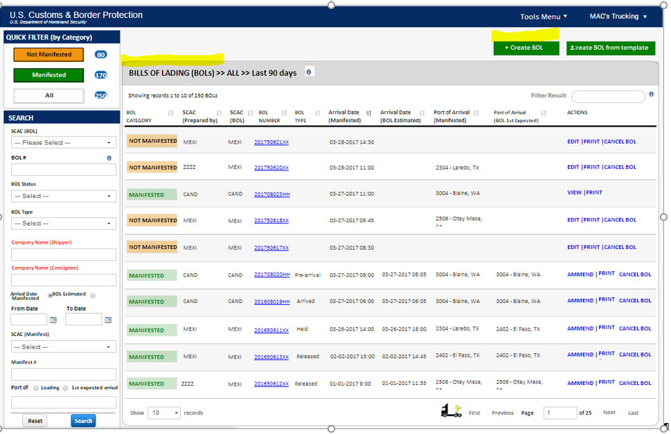3 BOL Listing Mockup
3.06 Once ACE receives an entry number for the bill of lading, ACE must display for the carrier that an entry number has been received and have the ability for the carrier to retrieve the entry number on file. The entry number does not need to be displayed on the landing page, a pop-up or hover over option would be acceptable.

Bill of Lading History
3.07 ACE must retain the bill of lading history for the trade user to review which portal user within their account took actions. The history does not need to be displayed within the landing page, a pop-up or hover-over would be acceptable to review this information.

4 Create a Bill of Lading

4.01 ACE must provide the capability to create, edit, and view the bill of lading information including the bill header information, the commercial parties on the bill, and the cargo commodity information to be saved as a standalone bill.
4.02 ACE must allow the trade user to add BOL header information, BOL Party information, and BOL Commodity information.

Bill of Lading Header
4.03 ACE must allow the trade user to submit the following BOL header data elements:
- SCAC Code for the BOL (Mandatory, should default to the manifested carrier SCAC)
- BOL Number (Mandatory)
- BOL Type
  - Regular Bill (formally known as PAPS)
  - In-Bond – 61, 62, 63, and In-Transit
  - PN Confirmation – Envelope Number
  - Section 321 Release
  - Unaccompanied household goods – CBP Form 3299
  - US Goods Returned – CBP Form 3311
  - General Headnote 1 Exemptions
  - FAST Shipment
  - 10.41a Instruments of International Traffic
  - Carnet
  - International Mail Shipment
  - Department of Defense Shipment – 19 CFR 10.102/103
  - Foreign Trade Zone Shipment
- Foreign Port of Loading (Mandatory, Search from IATA or Schedule K codes)
- Place of Receipt
- Service Type
- Transfer Destination (Search from FIRMS code look up, required if moving cargo on a permit to transfer)
- SCAC of authorized account (if another carrier should be granted access to shipment)
- First expected Port of arrival (Mandatory, if adding from to a manifest, ACE should default to the first expected port of arrival on manifest)
- Estimated Date of Arrival (Mandatory, if adding from to a manifest, ACE should default to the first expected date of arrival on manifest)
- Estimated Time of Arrival (Mandatory, if adding from to a manifest, ACE should default to the first expected time of arrival on manifest)
- FDA freight indicator

Bill of Lading Parties
4.04 Shipper: ACE must provide the trade user the ability to add a shipper to the BOL as a stand along shipper record and from a saved profile (See 4.05 and 4.06)
4.05 Stand Alone Shipper Record: ACE must provide the trade user the ability to add the following data elements for a BOL:

    - Company Name
    - Phone Number
    - Fax Number
    - Email Address
    - Address Line 1
    - Address Line 2
    - Address Line 3
    - Address Line 4
    - City
    - State/Province
    - Zip Code
    - Country (Should default to the country the state/province is located in)
4.05 Shipper data elements
4.06 Saved Shipper Record: ACE must allow the trade user to query saved shipper records in the company’s ACE party profile list. When this option is selected, ACE must give the trade user the list of saved Shipper to add to the BOL.
4.07 Note: If the carrier creates a stand-alone shipper record, ACE must provide the trade user the ability to save the shipper record to the ACE party profile list.
4.08 Consignee: ACE must provide the trade user the ability to add a consignee to the BOL as a stand along shipper record and from a saved profile:

4.09 Stand Alone Consignee Record: ACE must provide the trade user the ability to add the following data elements:
    - Company Name
    - Phone Number
    - Fax Number
    - Email Address
    - Address Line 1
    - Address Line 2
    - Address Line 3
    - Address Line 4
    - City
    - State/Province
    - Zip Code
    - Country (Should default to the country the state/province is located in)
4.09 Consignee Data Elements

4.10 Saved Consignee Record: ACE must allow the trade user to query saved consignee records in the company’s ACE party profile list. When this option is selected, ACE must give the trade user the list of saved Consignees to add to the BOL.
4.11 Note: If the carrier creates a stand-alone shipper record, ACE must provide the trade user the ability to save the consignee record to the ACE party profile list.
4.12 ACE must provide the trade user the capability to clear the shipper/consignee information from the page.

Bill of Lading Commodity Information
4.13 ACE must provide the trade user the ability to add a commodity information to the BOL:
- Commodity Description
- Quantity
- Unit of Measure
- Weight
- Unit of Measure
- Hazmat UNDG code
- Hazmat Point of Contact Name
- Hazmat Point of Contact Phone Number
- Commodity Equipment (default to the equipment on the manifest, provide ability to change, or provide drop down if multiple equipment records exist)
4.13 Commodity Data Elements
4.14 ACE must provide the trade user the capability to clear the commodity information from the page.
4.15 Split BOL’s: ACE must provide the carrier the ability to indicate a split bill of lading. A split bill of lading will have a single BOL number, a total BOL quantity, and a boarded BOL quantity. ACE will track each release of the boarded quantity and send a release notification at the conclusion of the full quantity entering the United States.

Link a BOL to a saved Manifest
4.16 ACE must provide the ability to link a standalone bill to a saved manifest.

Create a Bill of Lading Template
4.17 ACE must allow the trade user to create a BOL from a previously saved Template. Manifest templates will be saved without BOL information and BOL templates will be saved without manifest information.

5 Party Profile Landing Page

5.01 ACE must provide a party profile landing page that provides the capability to view, filter, and search BOLs created by the trade user.
5.02 The party profile landing page should default to show all party profiles and the data elements should include:
- Category
- Profile Name
- Party Name
- SCAC
- Party created by Name
- Last Modified Date
- Actions
  - Edit
  - Assign
  - Remove
5.02 Party Profile Data Elements

Party Profile Filters
5.03 ACE must provide quick filters that will sort the party profile types listed on the landing page by party profile type. Party profile types include:
- Consignee
- Crew
- Shipper
- All (default)
5.03 Party Profile Filters

Party Profile Search
5.04 ACE must provide a way for the trade user to search the party profile landing page to refine the records displayed. ACE must allow the trade user to search using the following criteria:
- Party Type
- Profile Name
- Party Name (Company)
- Party First Name (Crew)
- Party Last Name (Crew)
- CDL Number (Crew)
- Date of Birth
5.04 Party Profile Search Criteria
5.05 ACE must include a legal acknowledgement when searching for crew information. Example:
“Your use of the First Name, Last Name, Date of Birth, and/or Commercial/Enhanced Driver License Number for referenced individual constitutes your acknowledgement to CBP that you are authorized to access his/her personally identifiable information. Please check here to acknowledge []”.
(See also screen shot next page)

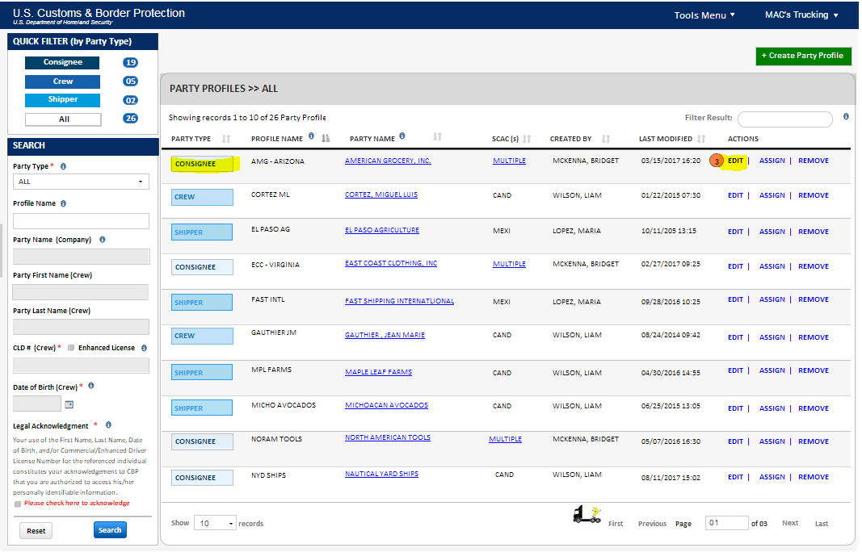5.05 Party Profile Search Mockup

6 Party Profile Management

6.01 ACE must provide the capability to create, edit, and view party profiles for Shippers, Consignees, and Crew Members.

Create Crew Members
6.02 To create a saved crew member, ACE must provide the trade user the ability to add the following data elements (including optional documentation data elements):
  - Personal Information
    - Gender (Mandatory)
    - First Name (Mandatory)
    - Middle Name
    - Last Name (Mandatory)
    - Name Suffix
    - Date of Birth (Mandatory)
    - Citizenship/Nationality (Mandatory)
  - US Address for Documentation
    - Address Line 1 (Mandatory)
    - Address Line 2
    - Address Line 3
    - City (Mandatory)
    - State (Mandatory)
    - Zip Code (Mandatory)
  - Crew Member Documentation (Mandatory for the first Driver)
    - Commercial Driver’s License (Must indicate if enhanced & if has Hazmat Endorsement)
    - Country
    - State/Province
  - WHTI Compliant Documentation (If the Driver’s License is not enhanced, at least one WHTI Compliant Document is required.)
    - SENTRI Card Number
    - NEXUS Card Number
    - Passport Number
      - Country of Issuance
    - Non-Immigrant Visa Number
    - Immigrant Visa Number
    - Laser Visa/Border Crossing Card Number
    - Permanent Resident Card Number
    - U.S. Alien Registration Card Number
    - U.S. Passport Card Number
    - DHS Issued Refugee Travel Document Number
    - Enhanced Tribal Card Number
    - U.S. Military ID Number (when traveling on official orders only)
    - U.S. Merchant Mariner Document Number
6.02 Party Profile Required Documentation Data Elements

- Citizenship Card Number
  - Country of Issuance
- Certificate of Naturalization Number
- Birth Certificate Number
  - Country of Issuance
  - State/Province of Issuance
- Other Number
  - Country of Issuance
  - State/Province of Issuance
6.02 (Continued) Optional Party Profile Documentation Data Elements

6.03 Note: For all documents requiring State and Country of Issuance, ACE must allow the state/province code to be entered and the country automatically populated based on State/Province selection.

Edit Crew Members
6.04 ACE must allow the trade user to edit crew members previously saved to the party profile list.

Create Shipper
6.05 To create a saved shipper, ACE must provide the trade user the ability to add the following data elements:
    - Company Name
    - Phone Number
    - Fax Number
    - Email Address
    - Address Line 1
    - Address Line 2
    - Address Line 3
    - Address Line 4
    - City
    - State/Province
    - Zip Code
    - Country (Should default to the country the state/province is located in)
6.05 Shipper Data Elements

Edit Shipper
6.06 ACE must allow the trade user to edit shippers previously saved to the party profile list.

Create Consignee
6.07 To create a saved consignee, ACE must provide the trade user the ability to add the following data elements:
    - Company Name
    - Phone Number
    - Fax Number
    - Email Address
    - Address Line 1
    - Address Line 2
    - Address Line 3
    - Address Line 4
    - City
    - State/Province
    - Zip Code
    - Country (Should default to the country the state/province is located in)
6.07 Consignee Data Elements

Edit Consignee
6.08 ACE must allow the trade user to edit consignees previously saved to the party profile list.

7 Vehicle Profile Landing Page

7.01 ACE must provide a vehicle profile landing page that provides the capability to view, filter, and search conveyance and equipment profiles created by the trade user.
7.02 The vehicle profile landing page should default to show all vehicle and equipment profiles and the data elements should include:
- Category
- Profile Name
- Type of Conveyance/Equipment
- First Plate
- Second Plate
- SCAC
- Created by
- Last Modified
- Actions
  - Edit
  - Assign
  - Remove
7.02 Vehicle Profile Data Elements

Vehicle Profile Filter
7.03 ACE must provide quick filters that will sort the vehicle profile types listed on the landing page by vehicle type. Vehicle types include:
- Conveyance
- Equipment
- All
7.03 Vehicle Profile Types

Vehicle Profile Search
7.04 ACE must provide a way for the trade user to search the vehicle landing page to refine the records displayed. ACE must allow the trade user to search using the following criteria:
- Category
- Profile Name
- Plate Number
- VIN/Serial Number
- Transponder ID
- Type of Conveyance/Equipment
7.04 Vehicle Profile Search Criteria
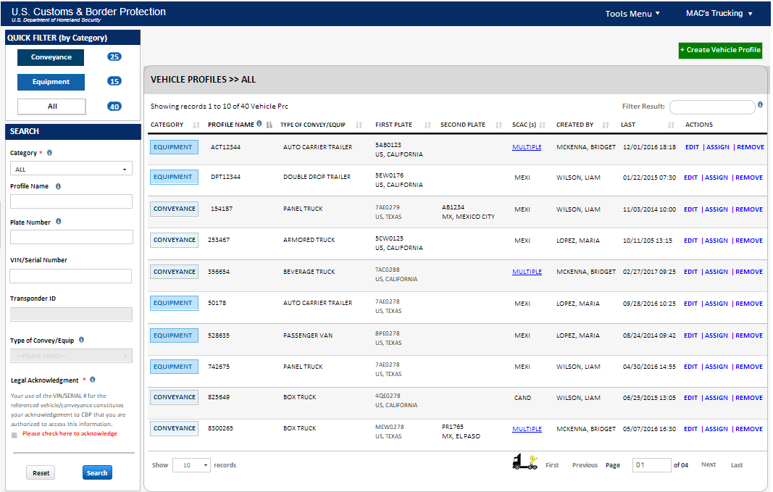7 Vehicle Profile Mockup

8 Vehicle Profile Management

8.01 ACE must provide the capability to create, edit, and view vehicle profiles for conveyance and equipment records.

Create Conveyance
8.02 To create a saved conveyance record, ACE must provide the trade user the ability to add the following data elements:
  - Conveyance Type (Required)
    - Armored Truck
    - Automobile
    - Beverage Truck
    - Bicycle
    - Box Truck
    - Bus
    - Construction Vehicle
    - Emergency Vehicle
    - Farm Tractor
    - Ferry
    - Garbage Truck
    - Motorcycle
    - Other
    - Panel Truck
    - Passenger Van
    - Pick Up Truck
    - Recreational Vehicle
    - Tractor
    - Van
- VIN/Serial Number (required)
- Conveyance Number
- DOT Number
- Transponder ID
- License Plate Number (at least one plate required, up to four allowed)
    - Country of Registration (ACE must
    - State/Province
  - Insurance Information (required if any shipment is flagged as hazardous material)
    - Company Name
    - Policy Number
    - Liability Amount
    - Year of Issuance
- Tractor Seal Number
8.02 Conveyance Data Elements

Edit Conveyance
8.03 ACE must allow the trade user to edit conveyance records previously saved to the vehicle profile list.

Create Equipment
8.04 To create a saved equipment record, ACE must provide the trade user the ability to add the following data elements:
  - Equipment Type
  - Equipment Number
  - License Plate Number
  - License Plate State
  - License Plate Country
  - 2nd License Plate Number
  - 2nd License Plate State
  - 2nd License Plate Country
  - Seal Number (trade can provide up to six seal numbers for each piece of equipment)
8.04 Equipment Data Elements

Edit Equipment
  - ACE must allow the trade user to edit equipment records previously saved to the vehicle profile list.

N9 Manifest template Landing Page
Manifest template landing page
N9.01 ACE must allow the trade user to view a manifest or a BOL from a previously saved Template. Manifest templates will be saved without BOL information and BOL templates will be saved without manifest information.
N9.02

N10 Manifest template Landing Page

N10.01 ACE must allow the trade user to view a manifest or a BOL from a previously saved Template. Manifest templates will be saved without BOL information and BOL templates will be saved without manifest information.

